**API Mobile Apps YogaFit**

*Source Sample FitHub

* Saat Apps Pertama di buka

Notes : Untuk background bisa di sesuaikan warna apa yang cocok

* Menu

Menu Saat Belum Login **“Join Now**” tp kalau udah Login Scan **“My Contract”** Nanti di update lagi ya buat fix nya penamaan nya. Class Ganti Schedule

* Menu Home

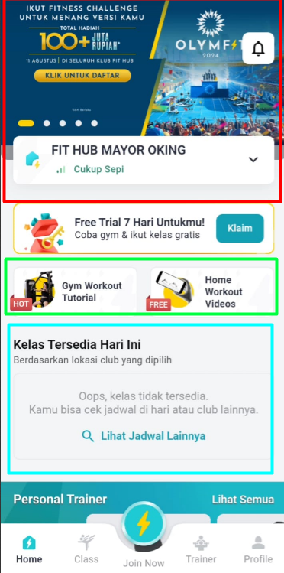

1. Banner Slider

API : https://login.yogafitidonline.com/api/api/auth/slider

1. Location Studio

API : <https://login.yogafitidonline.com/api/api/auth/get_studio>

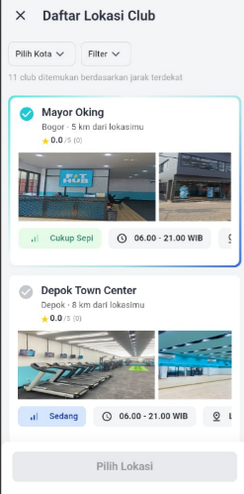Notes :

1. Filter Ga Usah
2. Footer nya Berisi -> Jam Operational, Link WA , Link Location, Fasilitas (Muncul Modal Aja Kali ya biar liat Detail nya)

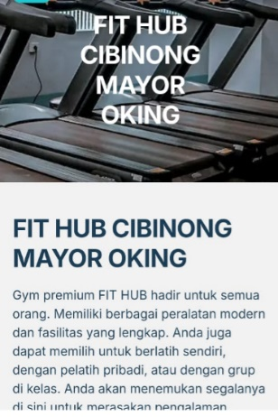

1. Seinget gw ada tar gw tanyain lagi ya
2. A group of people exercising

   Description automatically generatedA screenshot of a phone

   Description automatically generated Data Class yang udah di booking

API : <https://login.yogafitidonline.com/api/api/member/my_booking>

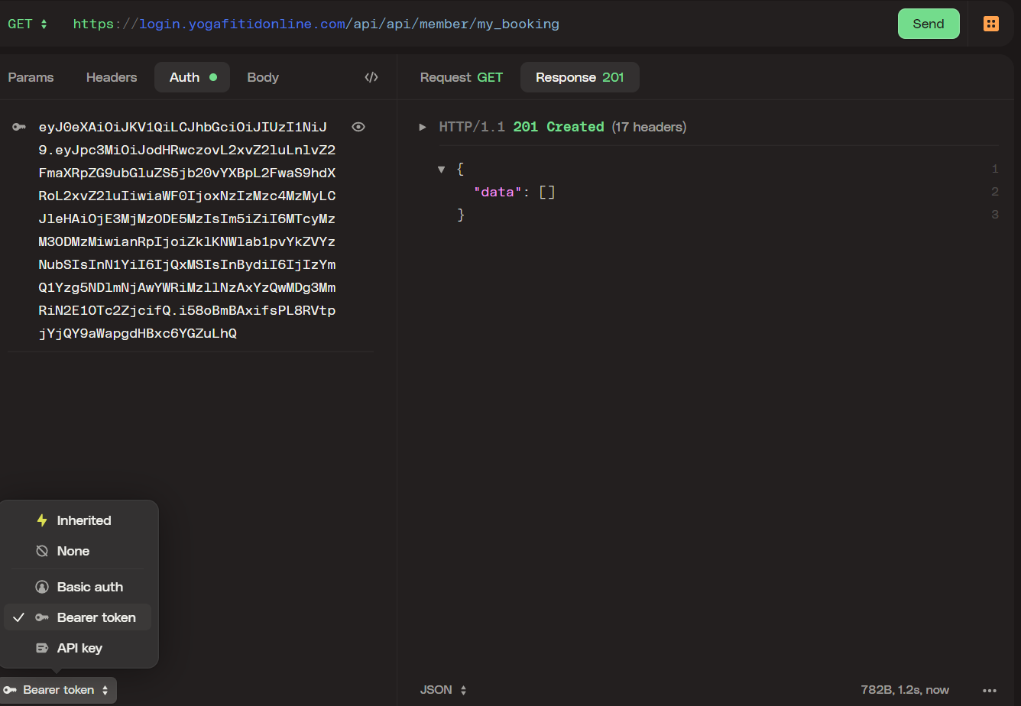

Notes : Kalau Belum Login atau Belom ada jadwal class yg di booking Muncul yang di Kanan

* Menu Schedule

API : <https://login.yogafitidonline.com/api/api/auth/get_users_schedule?id=2024-08-10&studio=&level=&classkat=>

Ket :

Id = Tanggal Format YYYY-MM-DD

Studio = Kode Studio Di ambil dari Get Studio -> Kode

Level = Di Ambil dari Class Level Get Class -> class_level

ClassKat = value Normal, Hot, Beginner

Notes : Tambah Filter Studio, Class Level, Class Kategori, Saat Booked nanti di API gw ada Validasi Members .

Kalau Sukses Berhasil Booking kalau tidak Ada Response Message

API Boking Class : <https://login.yogafitidonline.com/api/api/member/booking_class>

* Menu Join Now / My Contract

1. Join Now (Saat Belum Punya Akun)

Nanti Akin Kirim OTP by WA dan udah otomatis dapet contract dengan Type Trial

1. My Contract (Saat Udah Login)

API : <https://login.yogafitidonline.com/api/api/member/my_contract>

Field yang di tampilkan : name, deptname, packages_name, type, status_contract

Status : 0 Aktif, 1 Tidak Aktif, 2 Waiting Approve Cuti, 3 Cuti, 4 Trial

Notes : Saat Klik Contrack nya muncul Barcode nya Yud

<https://login.yogafitidonline.com/api/storage/qrcode/FileBarcode.png>

field nya **referal_code**

* Menu Trainer

API : Tar Gw Update Ya

* Profile

Akses Login : <https://login.yogafitidonline.com/api/api/auth/login>

Ambil token nya buat akses fuction api lain (yang butuh akses login)

